Chapter 4 – Python

Looping
- For – continue looping
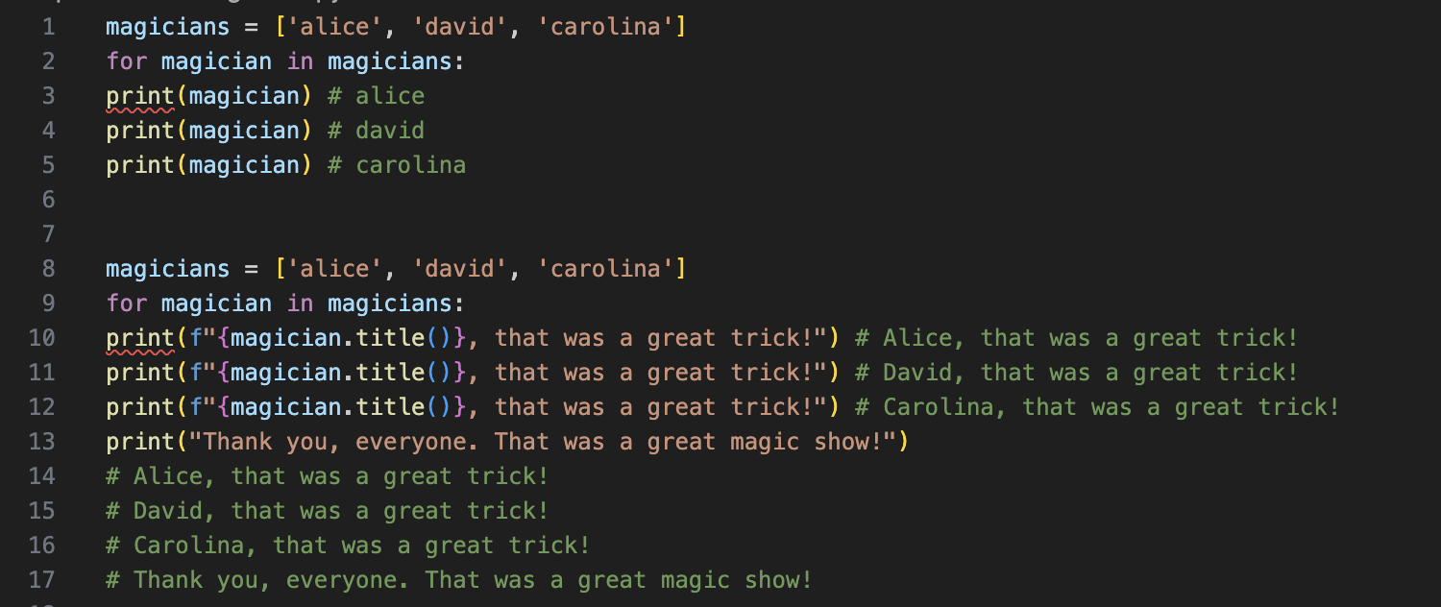
Avoiding Indentation Errors

